**English**

**Booster!**



**Assessment focuses for writing:**

**You will be assessed for your ability to:**

1. write interesting, imaginative and thoughtful texts.
2. produce texts which are appropriate to task, reader and purpose.
3. organise and present whole texts effectively by ordering and structuring information, ideas and events
4. construct paragraphs, making effective links within and between paragraphs.
5. vary sentences for clarity and effect.
6. write accurately and punctuate correctly.
7. select appropriate and effective words.
8. use correct spelling.

You **absolutely** need to use **capital letters** properly in your writing. This means **only** at the **start of sentences** and for **names**. If you use them mid-sentence you need to **stop.**

If you don’t use **more** **punctuation** than a full stop you won’t get a level 5! **Use:** speech marks, question marks, semicolons, colons, exclamation marks and commas. **MAKE SURE YOU USE THEM CORRECTLY!**

Use **clear paragraphs** or you won’t even get a level 4!

You also need to use a **range of sentences:** simple, complex and compound. Get into the habit of changing your order around!

**Do all these and you won’t have to hit the red warning button!**



**FLAP**

**F – Form**

**L – Layout**

**A – Audience**

**P - Purpose**









**FLAP these on your own!**

1. **Write a newspaper article for your school magazine to review your school trip to London Zoo.**
2. **Write a letter to Simon Cowell to persuade him to hold the X Factor final in Southall.**
3. **Write an email to the BBC to complain about a programme you watched.**



**Argue, Persuade, Advise**

**Writing to argue could be:**

* Pamphlets
* Newspaper articles

**In terms of what you should include, it should have:**

**Opening paragraph:**

An effective opening statement such as: *How can people actually think that school uniform is a great idea?*

Where they get the reader on side such as: *It is obvious what has to be done, isn’t it? An intelligent reader such as you can patently see that.*

Where they use false facts: *80% of schools without uniform tend to score higher in the league tables.*

**Main body of the text (2 or 3 paragraphs)**

Addressing of the argument such as: *Some people think that school uniforms help breed a culture of discipline and control.*

Contrast connectives such as: *On the other hand,*

Counter argument such as: *Uniforms are stifling our children’s creativity and hindering their learning.*

Addition connectives: *As well as this,*

Continue counter argument: *It could be argued that uniforms are actually distracting students from listening. They may feel uncomfortable while attempting to pay attention.*

**A conclusion, which should:**

wrap up the main points such as: *It is clear to right minded people that uniform is simply being used to control and dominate our children. This is, at a time, when they need to be encouraged as well as focused.*

Rhetorical question: *Why would you want to feel uncomfortable?*

Pattern of three: *Uniforms are outdated, out of fashion and out of time.*

Strong finishing statement: *Let’s take the uniform off and leave it off, once and for all!*

**Model: Writing to argue:**

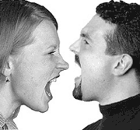

What would happen if you, an intelligent adult, woke up one morning and you were forced to wear exactly what someone told you? Psychologists say this form of control can constrict a person’s thought processes and lead to inhibition. Obviously, you wouldn’t want to do something like that; especially in an environment where thought processes are vital for success.

Some people would argue that school uniforms make students better behaved, more ready to respect the systems the school has in place. Haven’t they even bothered to think that it could be harming students’ ability to concentrate properly? Surely it also helps to make them less comfortable as they sit, period after period, in stifling heat wearing shirts and ties.

As well as the behaviour, other people have said that a uniform actually helps students learn. On the flip side of this preposterous suggestion, teachers have to constantly waste valuable learning time checking that students are wearing the uniform correctly. As well as this wasted time it can also lead to friction if a teacher is being too unrealistic about the uniform.

Continuing the arguments for uniforms are those people that say the uniform helps make young people presentable. On the contrary, students can still look very presentable in their own clothes. A range of high street fashion is, nowadays, both functional and neat enough to be worn to school. In addition, students could have a firm set of rules governing the casual clothes: this would ensure fairness all round the student body.

It is obvious what choice has to be made, isn’t it? Students need to feel comfortable, have more learning time and be able to look presentable. They can do this while wearing their own clothes. Let’s make the change for the better.

**Revision task:**

**Write a counter-argument against capital punishment (against killing people for their crimes). Don’t forget to address the argument that capital punishment should be supported! Then destroy that by introducing and extending the opposing view.**

**Writing to Persuade**





**Writing to persuade could be:**

* Leaflets/Posters
* Speeches
* Letters

**In terms of techniques, the writing should have:**

* **Strong opening sentence such as:** The idea that “young people today have no time for anyone but themselves” is preposterous in the extreme.
* **(False) Facts:** 97% of teenagers do chores
* **Opinions presented as facts:** Young people make many positive contributions in both my local community and in society at large.
* **Rhetorical questions:** How can the opening statement be true?
* **Groups of three:** Young people are confident, kind and generous.
* **A range of sentences (complex, compound and simple):** Why just yesterday I saw a young boy, of about 13 or 14 years of age, who was standing out in the pouring rain collecting for charity. Hardly the act of someone with no time for anyone but himself, eh?
* **Emotive language (strong words):** preposterous, nonsense, outrageous, hurtful etc.
* **Similes:** Young people are like young charity workers
* **Exaggeration:** Teenagers are simply incredible. The world wouldn’t function without their important actions.

**You need to put these techniques in a piece of persuasive writing as and where you see fit. Aim for two techniques per paragraph. This will help keep your writing fairly balanced.**

**Model: Writing to Persuade**

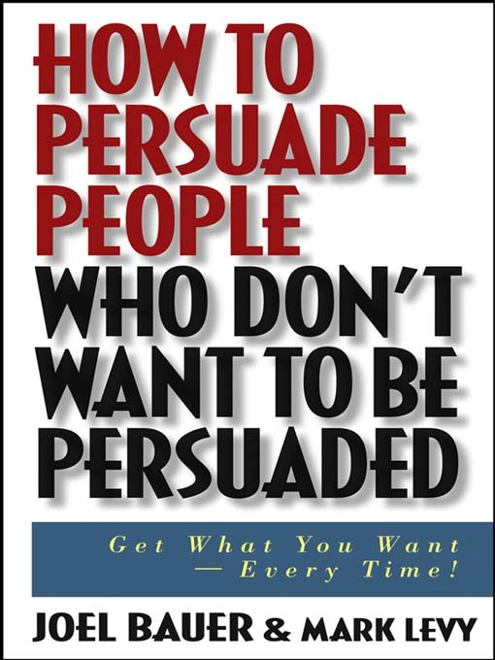

The idea that “young people today have no time for anyone but themselves” is preposterous in the extreme. To generalise teenagers like that is unkind, unfair and uncalled for. Young people make many positive contributions in both my local community and in society at large.

Also, recent research has shown that 97% of teenagers do chores. That leaves a minuscule 3% who are not pulling their weight. It is hardly enough proof for the statement to be true, is it? Why just yesterday I saw a young boy, of about 13 or 14 years of age, who was standing out in the pouring rain collecting for charity. Hardly the act of someone with no time for anyone but himself, eh?

Young people are confident, kind and generous. The idea that they are selfish is nonsense. Some of the local council’s initiatives are well served by the younger generation and I always see them helping out around festival time. School councils also give students the opportunity to give something back and many young people jump at the opportunity. How can the opening statement be true?

Moreover, because of the actions of a few idiotic young people, all the rest of the young people get tarred with the same brush. It is outrageous and hurtful. This kind of discrimination is shameful and must stop. It will only force young people into a scenario where they will become selfish. Let us celebrate young people and the good deeds they do. They are the best in the country and they are the best in the world. That’s not so preposterous, is it?

**Revision task:**

**Write an article for a school magazine in which you aim to persuade your readers that smoking is a bad idea. Don’t forget to use clear paragraphs grouped by topic!**



**Writing to advise**

**This type of writing would make up:**

* Recipes
* Manuals

**It should include the following techniques:**

** Imperative verbs (verbs that give direct orders):** e.g. ‘Put’, ‘Grate’

** Prepositional phrases (phrases that give an indication of position):** e.g. ‘Above your head’, ‘Under your seat’

** Active sentences (Sentences which have the subject doing something to an object):** You peel the potato

** Use of colon prior to lists.**

** Use of second person:** You push, You cut, you open

** Sequential connectives, e.g. ‘First, ‘Secondly’ etc**

** Sequential: The text follows a clear, structured order**

** Clear unfussy central layout**

** Easy to scan for next instruction**



**Model: Writing to advise**

Ingredients:  
1 ounce/25 g butter   
2 pounds/900 g lamb or beef, cubed   
1 large onion, coarsely chopped   
2 carrots, chopped   
1 Tbsp plain flour (optional)   
1/2 pint/275 ml beef stock   
2 Tbsp tomato puree   
1/2 Tbsp sugar   
2 potatoes, cubed (optional)   
1 bottle of Guinness or a large glass of red wine   
1 bouquet garni (sprig of parsley, sprig of thyme, 1 bay leaf tied up in muslin)   
Salt and freshly ground black pepper   
Tabasco sauce

Instructions:  
Firstly, melt the butter in a large pan. Secondly, fry the meat in it until browned on all sides. Do not crowd the pan; Thirdly, you, then, brown the meat in two or three batches if necessary. Fourthly, after that, you remove the meat from the pan, add the onion and carrots and cook until slightly softened.

At this time, you return the meat to the pan. Sixthly, add the flour, if using, then stir in the stock, tomato puree and sugar. Seventhly, bring to the boil and then reduce the heat to a simmer. Finally, add the potatoes, if using, the Guinness or the wine, the bouquet garni and salt and pepper to taste.

You have to cook over a low heat for about 1 to 1 1/2 hours or until the meat is tender. Finally, while the stew is simmering, add 4 or 5 drops of tabasco to taste.

Yield: 4 servings.

**Revision task:**

**Write a recipe for making beans on toast. Don’t forget to lay out the text in sequential order (the order that things should be done in).**



**Inform, Explain, Describe**

**Writing to inform would be used in these texts:**

❑ Leaflets

❑ Reports

❑ Eye-witness accounts

❑ Prospectuses

**The following techniques would be used:**

❑ Technical / specialist vocabulary: language specific to the area of the text. For instance a prospectus for a school may talk about curricula, academic achievement and vocational courses.

❑ Causal connectives: because, as a result of, so, because of this, this causes

❑ Present tense: This is happening because. When you do this ensure that.

❑ Formal: Use Standard English and formal language.

❑ Third person generic: Don’t use I. Remember you have to write from a third person point of view: The sauce then needs to be added and mixed thoroughly as **opposed to** I would add the sauce.

❑ Active and passive voice: Add the sauce **as well as** the sauce is then added are both acceptable sentence constructions.

❑ Tendency towards simple and compound sentences.

❑ Clear topic sentences: a sentence at the start of paragraphs that sums up what it will be about.

❑ Different fonts

❑ Bullet points

❑ Headings and subheadings: to break up the information

❑ Tables / Text boxes: to lay out the information neatly

❑ Diagrams

❑ Paragraphs likely to be organised by topic e.g. habitat, breeding habits.

**Model: Writing to inform**

**Jovshire Council**

**Environmental Policies and Activities**

Jovshire council have decided to continue pumping money into the local environment. This helps ensure that everyone in the area is playing a part in reusing and recycling materials. This leaflet has all the details of how we plan to continue playing our part for the environment. It provides information on our recycling policy, how residents can do it and the leaflet also has details of our environment volunteer group. Read on to find out more:

**Recycling in Jovshire:**

The council are continuing the policy of using the colour coded bins for collections:

* **Green for paper as well as paper products**
* **Yellow for glass, hard plastic and cans**

Residents are reminded that these are collected every two weeks on a fortnightly cycle (Green one week, yellow the next). Recycling locally creates jobs in the area so play your part!

**Out size recycling:**

Any products which do not fit the traditional recycling bins or policy can be left at the local refuse depot. This would include products such as: old computers, fridges, washing machines, vacuum cleaners.

**Environment Volunteer Group:**

In conjunction with the continued push on recycling the council have decided to start a volunteer group. The group will convene every weekend as well as on Wednesday afternoons. On these days the group will be held at the Countryside Warden’s office on Kell Lane. Any further information can be obtained through the Environmental Department, council buildings, Jovton.

**Activities**

There will be a wide range of activities, which will include:

* Pollution testing – the group will visit several sites, checking that the minimum safety levels are being adhered to.
* Clearing ponds, canals, rivers – this will help boost local wildlife numbers and variety ensuring the local area remains a vibrant natural habitat

**Residents can see that the council remains committed to the environment through our recycling efforts as well as the new volunteer group. Play a key role in our efforts! Come along or contact us on the freephone number!**

***Revision task: write an article about a hobby or pastime you enjoy. Make sure you break the information down for the reader!***

**Writing to Explain:**

**The following texts would all be explanatory in nature:**

* Summaries
* Report
* Encyclopaedia entries

**Some of the following techniques would be used:**

* Connectives to indicate the order in which the text is written (Firstly, secondly etc.), to show cause and effect (thus, therefore, as a result of…) or to indicate comparisons (in comparison to, compared with etc.)
* Technical/Specialist vocabulary (A report on a school may involve words like curriculum, academic, courses, pastoral etc.)
* Impersonal tone
* Written in the third person (No “I” used)
* Mostly active voice (The students attend classes as opposed to the classes are attended by students)
* There may be diagrams or illustrations
* Paragraphs open with a general statement followed by evidence to back it up.
* The text is written in a logical order.

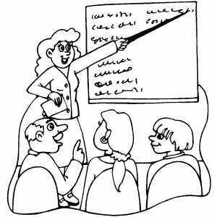

**Model: Writing to explain**

**How are sedimentary rocks formed?**

Compared to igneous rock, sedimentary rock is formed by the compression of layers of particles into a solid form.

Firstly in the process, sediment such as sand and mud settles on the floors of oceans and lakes. Secondly, over a long period of time, several layers of sediment collect on the floor. Thirdly and gradually, these layers are pressed together for many thousands of years. As a result of the long periods of time, the small solid particles of mud and sand are fused together to form rock. This type of rock is called sedimentary rock.

**Revision Task:**

**Write an entry for an encyclopedia, informing the reader about a topic you know a lot about. Make sure to use the conventions of writing to explain. You might also want to drop in specialist vocabulary specific to your pastime!**

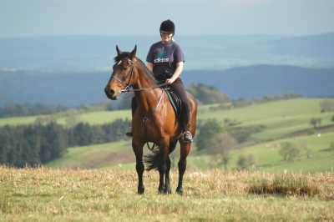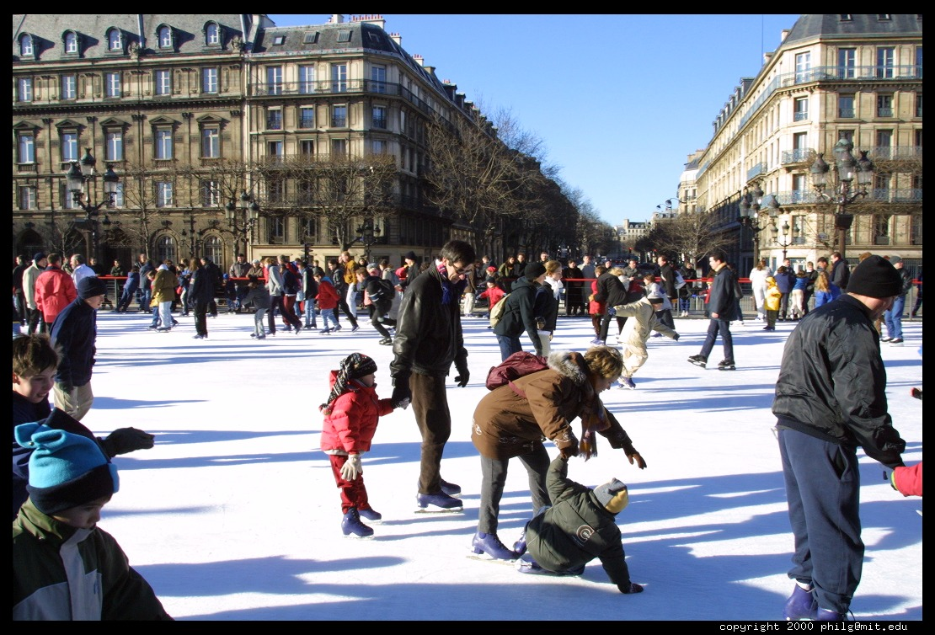

**Writing to Describe:**

**This writing would be used in:**

* Eye witness accounts
* Stories
* Autobiographies

The following techniques would be extremely useful:

* **Pattern of three:** The house was bleak, lonely, and desolate.

* **Paragraphs:** Take a new one every time a new time, person, topic or place is introduced.
* **Punctuation:** This should help organize your writing. Commas to break up big sentences, exclamation marks to indicate excitement and semicolons to separate closely connected clauses.
* **Adjectives:** The **harsh, cutting** laugh echoed around the walls.
* **Adverbs:** The man walked slowly and stealthily towards the unsuspecting boy
* **Metaphors and Similes: M -** He was a vulture circling ready to swoop.

**S -** I stood waiting, like a silent sentry on guard patrol.

* **The five senses:**

**Sight:** He looked around him, sunlight assaulted his eyes.

**Sound:** BOOM! The bomb shook the foundations of the building.

**Taste:** It had a peculiar, tangy taste. The water rushed round his mouth.

**Touch:** It felt smooth to the touch: a soft, velvet smoothness.

**Smell:** There it was again. That sour, infectious smell: like three week old milk.

**Writing to Describe: Model**

The house was lonely, bleak and desolate. Ray gulped as he ran his eyes up and down the huge, wrought iron gates that loomed over him. He felt like a frightened child as he stood there, pulling his head into his collar, fighting the cold. The wind whipped round him viciously, cutting into his eyes, bringing tears that rolled swiftly down his face.

It was time. Time that he faced his fear and enter the house. He pushed the gate; it creaked noisily as it swung in its hinges. Then, it swung out of his hand and CRASH!! The gate clattered against the wall. Bits of rust fell on the ground from the impact. The echo reverberated around the neighbourhood: Everybody must have heard. If they didn’t know he was coming, they would now!

He stepped onto the greasy paving stones that led the way to the barren, rickety porch. His shoes slipped as he quickly steadied himself. He walked gingerly forward, making sure he wouldn’t slip. Rain started now, straight into his face, slicing across his cheeks.

Suddenly his nostrils picked up attentive to a new smell. Aromas filtered into his nose. What was it? He couldn’t place it. It was almost calling him, beckoning him towards the house. He was a slave to the call.

He was there, the steps to the house spread before him like a great red carpet presaging his doom. The steps were traversed quickly. “Get it over with!” he thought. He pulled the door open. The wind chimes clanged. He gulped and said “Sorry, I’m late Mum!”.

**Revision task:**

**Write a description of a place which is unwelcoming or isolated.**

**In your writing, try to use a variety of sentence structures and interesting vocabulary to create a sense of place for the reader.**

**You could write about a place which is:**

* **real or made-up**
* **busy or deserted**

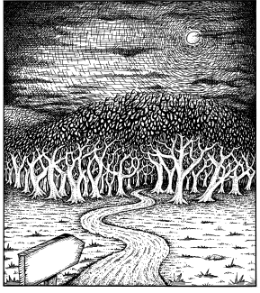

**Analyse, review, comment**

**Writing to analyse:**

**This writing would be found in:**

* Essays

**It asks you to consider different viewpoints on an issue and would use the following kinds of writing techniques:**

* Be written in present tense
* Expressive verbs (shows, implies, exemplifies, proves…)
* Third person (to show formality)
* Connectives: however, moreover, whereas, although, therefore, as a result…
* Solid topic sentences expanded using PEAS

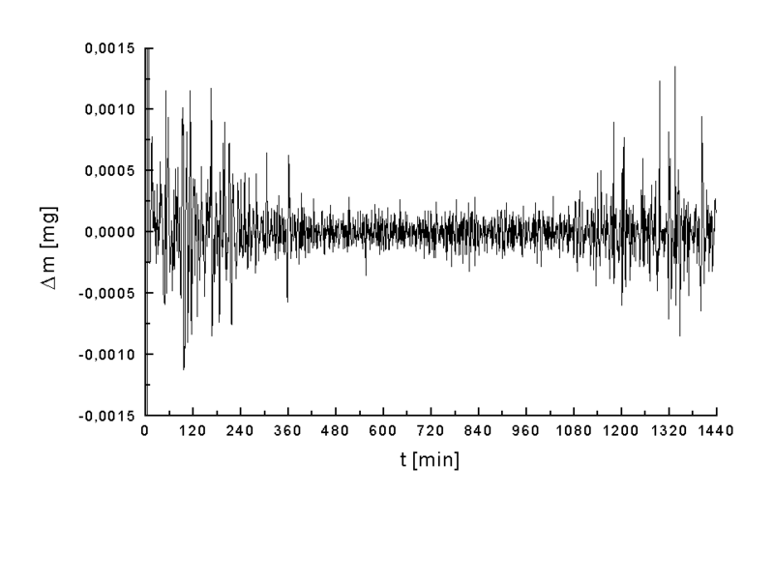

**Model: Writing to analyse**

Forest Futures

One of the most controversial environmental issues concerns the future of our forests. Debate centres on whether we should preserve the forests in their natural state or whether we should allow them to be logged.

On the one hand, conservationists argue that we need to put a stop to the destruction of this natural resource. In Brazil, for example, the rainforest is disappearing at an alarming rate, depriving native tribes of their habitat and depleting the earth’s supply of oxygen.

On the other hand, developers claim that forests are a renewable resource and that human kind has an urgent need of the products provided by the forests such as timber and woodchips. Moreover, the logging industry is a major employer and if logging were stopped, several thousand people would be out of work.

This all serves to show that while it would seem apparent that some form of logging is inevitable in the short term, in the longer term we need to develop alternatives to using timber from natural resources.

**Revision task:**

**Write an essay on: How is the character of The Nurse portrayed in her scenes? Don’t forget to use clear paragraphs based around key quotations. Analyse them in detail and link your paragraphs! You are revising both your reading and writing in this task!**

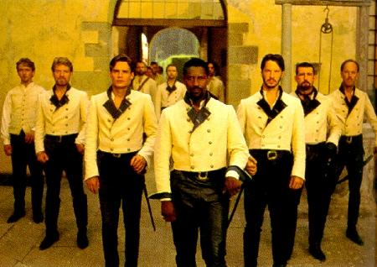

**Writing to review**

This kind of writing is used in, shock horror, reviews!

**This writing asks you to summarise and give your opinion. It uses a range of techniques:**

* Verbs that give opinions or reflections: believe, feel, consider, suppose.
* Use of modal verbs: It MIGHT be considered that. The actors SHOULD have …
* An opinion should be expressed that gives a recommendation.
* A concluding comment should show exactly what the writer believes.

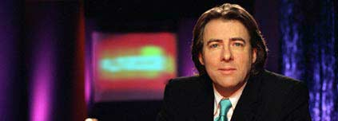

**Writing to review: Model**

This year’s hot new hope to emulate the swords and sandals success of *Gladiator* is the latest offering from *Dawn of the Dead* director Zac Synder. Called *300* it recounts the legend that 300 Spartans, led by King Leonidas, held a pass against a million invading Persians. So far, so unrealistic.

The film uses a distinct visual style and is heavily laden with CGI graphics. This could be considered a triumph of style over substance especially when you see the Judas-like character that betrays the men to their enemies. A horrendously rendered abomination, who instantly recalls Gollum from Lord of the Rings, the character is poorly realised and serves to take the viewer out of the world of the movie.

The fight scenes are peppered with ludicrous slow motion pans and zooms when it should let rip with fast, kinetic action. The battles are too often slowed down by this stop start approach. Throw in more ridiculous CGI monstrosities, poorly ripped from some design monkey’s imagination and soon this movie starts to really push things that little bit too far.

All things considered *300* should have challenged *Gladiator* for the role of Emperor. In the end, it can only be a pale pretender whose challenge is still-born from the outset.

**Revision task:**

**Write an review on a film you have seen recently. Don’t forget to use paragraphs. It might be an idea to look at:**

**Characters**

**Setting**

**Action**

**Computer Generated Effects (If there are any)**

**Show the reader what decision you have made and why you have made it.**

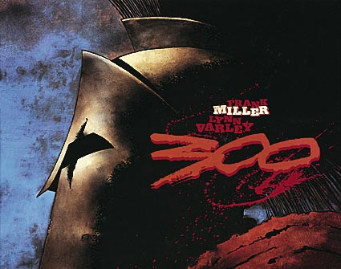

**Writing to comment**

**It would be found in:**

* Articles
* Commentary
* Reports
* Editorials in newspapers

**This kind of writing asks you to give a personal response to something. The following techniques would prove useful in writing to comment:**

* Use of first person to express personal responses
* Use of adjectives that show judgement: convincing, amusing, unbelievable.
* Use of subordinating connectives such as because, if, whilst, although
* Use of rhetorical devices for effect: repetition, rhetorical questions, exclamations etc.
* Strong topic sentences expanded using PEEL.



**Model: Writing to comment**

**My karate community**

I belong to an unusual community: my karate club. My karate club usually meets in the community centre in Westtown, Hayling. I go every Saturday morning from 11 to 12 and as I have been going for a couple of years, I know everyone well. One of my fellow members described the club as having “lots of families in it.”

There are many people in my club and I didn’t know them when I started out. But after a few weeks I knew most of them and was more comfortable being there. They are all so helpful and kind. When I started I thought that everybody would be really good at it, but lots were new – just like me. Our Sensei, Dan, is great. He is a black belt with seven dans (which means he is really, really good at it.) He reminds me of Hagrid, from Harry Potter and if he were a character in a book he would be the gentle giant. The only problem is that he says some things in Japanese. You wouldn’t believe what he does a job. He’s a nurse and I didn’t expect a nurse to be interested in self defence.

Belonging to this club has made me realise that I can defend myself if I had to and, as a result, I feel more confident about going out by myself, at night. That also makes me feel better about myself. I like the feeling I get from doing karate – it gives me a real buzz. The experience comes alive for me when I am wearing my gei (a cool karate suit) and my belt. It is a great feeling when we line up all ready for work. The only thing that I dislike is that the hall is always cold.

The most difficult thing for people outside to understand is that it is not just about kicking and punching. There are lots of things to learn. It takes a lot of hard work, concentration, dedication and discipline to be good at it.

Some people say that they can beat black belts, when, in truth, they would be flattened. My friends don’t think that I can be good at it because I am small. These attitudes really annoy me. I have worked hard to get to where I am and I am proud of what I have achieved.

! sometimes think about what I would be like if I didn’t do karate. I would miss the people that I got to know and the buzz that I get from doing it (but at least I wouldn’t get cold). I have always wanted to do karate and I really want to be a back belt although I know it will take me ages to get there.

I’ve tried to explain what it feels like to be learning something from a different country and culture. It is good fun and hard work but you meet new and exciting people. It is also great to be in a second family and that means a lot to me.

**Revision task:**

**Write a comment piece on the introduction of the vocational courses at Ashfield next year. What do you think?**

**Writing to Imagine, Explore, Entertain**

**Writing to Imagine**

**This would be found in:**

* Narratives
* Poems

**This writing would create a different world through writing using the following techniques:**

* Figurative language: metaphors, similes, personification.
* Strong verbs: “crept” instead of “walked”.
* Variety of sentence lengths: short sentences to show pace
* Punctuation used for effect: exclamation marks to convey excitement.
* Stories written in third or first person depending on what the writer wants to achieve
* Stories written in past or present tense.
* Text arranged into paragraphs (stories) or stanzas (poems).

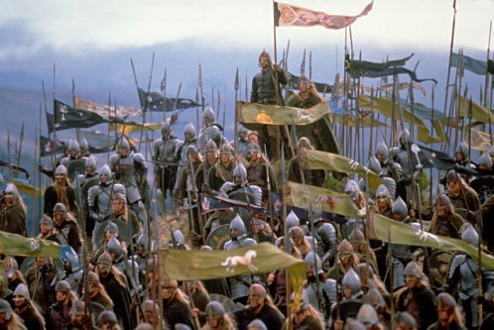

**Writing to imagine: Model**

**Apocalypse**

The darkness was growing and we were falling back. There were now only a few thousand people on Earth. Most civilians had been evacuated to the station which had now left for Mars.

Lieutenant Bud shouted up at me ‘There’s a path by that rock’ so we ran down to it and took cover. Unfortunately Mark Gray stayed behind, a suicidal attempt at saving his planet.

My squadron was nearly all dead, my sergeant had just been killed and moral was low, they needed a boost in confidence.

We were being surrounded and our only cover, the rock, was close to being destroyed but then after a missile had hit it I saw a crack appear and I remembered something very invaluable indeed.

I told my men to come closer, then I said ‘Turn on your shoulder lamps.’

‘Why?’ said private Ben Myers.

‘Just do it, and follow me.’ I said as I jumped towards the crevice which had gotten larger. The men followed as we descended into the catacombs.

We had been walking for one hour. I was very glad that I had taken private Salem’s bag after he’d been blown to smithereens because of the old maps he’d told me about.

The squadron was close to reaching the walls where the floating city used to be; before it got shot out of the sky, now all that was left was the magnetic mechanical base that caused the city to float. There was only one reason why I chose this route, the old magnetic lifts inside the base. ‘This could be the turning point in the battle’ I thought to myself.

**Revision task:**

**Write a piece on anything you like. Let your imagination run wild! Try and use complex and varied words for effect. Keep the reader interested!**

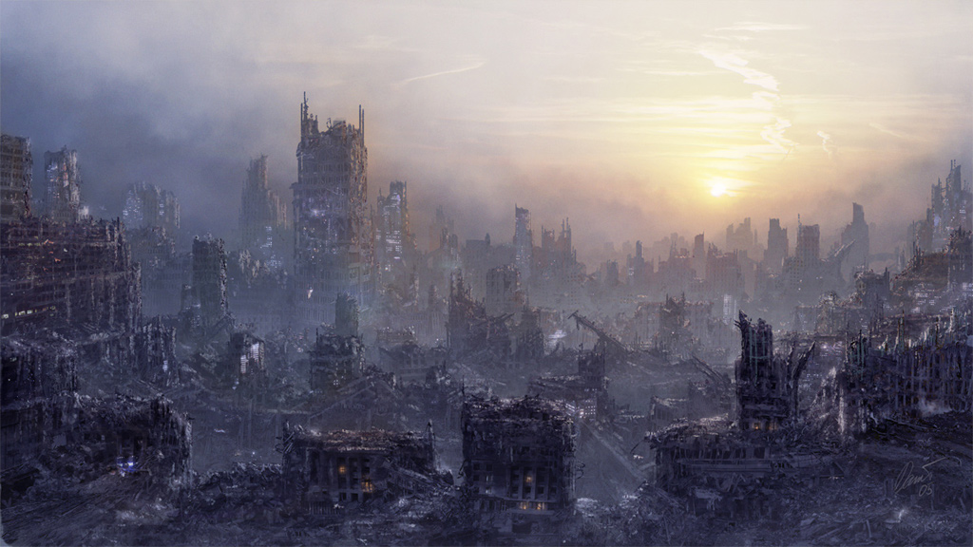

**Writing to Explore**

**This kind of writing would be evident in:**

* Diaries, letters
* Newspaper editorials
* Feature articles
* Discursive essays

**Feelings, thoughts, issues or events would be explored using these kind of techniques:**

* Modal verbs to show possibility: could, might, should.
* Causal connectives: consequently, therefore etc.
* If… then … sentences to again explore possibilities and consequences.
* First or third person chosen.
* Past or present tense could be used.
* A choice should be made between formal or informal depending on the purpose and audience for the piece.
* Linked paragraphs

**Model: Writing to Explore**

What a horrible day! TPS is so different from Herne. We are only going to have two break-times and really hard lessons but I suppose it will be exciting.

The first thing I saw when I arrived this morning was the huge gates and the even bigger school. I wondered if I could ever get to like coming to school each day and I felt quite worried about it.

I remember hearing people moaning about the first day of school, how they wanted the holidays to stay. There were hundreds of pupils and I was just walking in the middle of them, wishing I had someone to talk to. When I got to the safety of the year 7 playground I was quite relieved. Then, I found my friends who made me feel much better. We just talked about worries for the next ten minutes until the bell rang.

When we got to the tutor room we were told what was going to happen: that made us all feel better. After that we rushed to our first lesson (PE) not wanting to be late. When we got there, we waited outside until called for. Then, we sat down with our teachers and were told about the rules of PE. It was a bit disappointing as lots of us had hoped that we would do something on the first lesson. However, we didn’t have our kit as we didn’t know the timetable until that morning.

After that we went off to find our science lesson. We went in the exit and got crushed by a mass of bodies coming through the doors. When we got to Science bruised and battered, we ended up having an excellent lesson.

I thought at the time that it was going to be strange getting to know all these different teachers and that I couldn’t expect to like them all. Other lessons we had were Geography (boring) English (all right) and French (good). The best lesson was French because we did some French basics but we also played some games.

I realise that today is important because it is the beginning of secondary school. It is going to be very different from my primary school. I can never go backwards in time, only forwards.

**Revision task:**

**Write about your first day in school. How did you feel? What kind of thoughts were going through your head as you walked around? Did you like certain people? Dislike others? Focus on emotions here!**

**Writing to entertain**

**You can find entertaining writing in:**

* **Travel writing**
* **Biographies**
* **Parodies**
* **Scripts (plays, TV comedies, films etc)**

**This type of writing, while attempting to capture the interest of the reader and making the reader laugh, will use some of the following:**

* Colloquial language or jargon
* Rhetorical questions
* Appropriate choice of person and tense
* Linked paragraphs
* Humorous tone

**Writing to entertain: Model**

**Setting:** *In a toy shop - a girl of 6 wants choose a teddy bear, but the shop keeper does not like children and tries to get rid of her quickly.*

**Girl:** Excuse me.

**Shopkeeper:** (Said crossly) What?

**Girl:** Excuse me . . . I was

**Shopkeeper:** Why? What have you done? If you’ve had an accident . . .

**Girl:** (confused) No! No! I was just wondering whether you have any Pooh?

**Shopkeeper:** I knew it! If it isn’t one, then it’s the other. I thought I could smell something horrible. How dare you! In my shop! Of all places. You’d better clear up your mess before I get the police. Young people today have no respect.

**Girl:** (talking loudly over the shopkeeper) NO! I haven’t poohed . . . I want to know whether you have any bear?

**Shopkeeper:** (interrupting) Now don’t get rude with me, young lady. We don’t sell anything bare in this shop. I know your sort. You try to wind me up and laugh when I

lose my temper. Well, it won’t happen you know. All of our toys have clothes on.

**Girl:** (shouting now) Stop it! Don’t you listen to anybody! Pooh bears! Pooh bears! I WANT TO KNOW IF YOU HAVE ANY POOH BEARS! You know, the one that likes honey and has Eeyore as a friend. Don’t you know anything?

**Shopkeeper:** (grabbing the girl by her arm and marching her to the door) Right! That’s it. I have had enough of you. Shouting at me like that. Out you go and don’t you come back here again.

*Girl leaves and pulls a face at the shop keeper through the window.*

**Shopkeeper:** That’s got rid of another one. If I keep going like this I can go home soon.

**Revision task:**

**Write a humorous travel piece about somewhere you have visited on holiday. Try and get the reader laughing!**

**Varying Your Sentence Structure**

Rewrite the following sentences so that they do not start with the subject (i.e. ‘she or ‘he’). You can do this by:

1. Moving the verb to the beginning of the sentence, for example:

**She waited in the darkness until she fell asleep.**

becomes

**Waiting in the darkness, she fell asleep.**

1. Moving the final word at the end of the sentence to the beginning of the sentence, for example:

**She waited in the darkness until she fell asleep.**

becomes

**Sleep came upon her as she waited in the darkness.**

1. **Moving the whole of the second part of the sentence to the beginning, for example:**

**She waited in the darkness until she fell asleep.**

becomes

**Until she fell asleep, she waited in the darkness.**

**Now try changing the three following sentences so that they do not begin with ‘she’ or ‘he’:**

1. **She crept along the corridor until the darkness covered her.**

**………………………………………………………………………………………………………………………………………**

1. **He held his breath and waited patiently.**

**………………………………………………………………………………………………………………………………………**

1. **She wiped the tear away from her eye leaving a smear of mascara on her cheek.**

**………………………………………………………………………………………………………………………………………**

**Now change the sentences around in your own writing to make it more interesting. Use the examples above to help you. This will help you reach a solid level 5.**



**Connectives**

|  |  |
| --- | --- |
| **Examples** | Changing topic |
| for example | with regard to… |
| for instance | as far as...is concerned |
| such as | moving on to… |
| **Listing Points** | **Contrasting** |
| firstly, secondly, finally | however |
| in the first place | on the other hand… |
| to begin with | …although… |
| on top of this | despite this… |
| in addition to this | on the contrary… |
| more importantly | instead… |
| as well as | as for… |
| furthermore | …whereas… |
| another | …while… |
| not only…but also | **Cause and Effect** |
| before | …so… |
| after | as a result of… |
| **Comparison** | …because… |
| compared with… | this means that… |
| …in comparison with… | due to the fact that… |
| similarly… | …due to… |
| in the same way… | …therefore… |
| likewise… | ...caused… |
| equally… | this caused… |
| **Summing up** | to sum up… |
| in conclusion… | overall… |
| in summary… | on the whole…  **If**  If they were lucky...  If he could just...  If she reached...  If only they  **If**  If they were lucky...  If he could just...  If she reached...  If only they  **With**  With a sense of …  Without another ...  With the knowledge that...  With a last...  With a feeling of…  With hope in ...  **Feeling**  Feeling a little bit nervous …  Feeling as if …  Feeling excited I ……  Feeling exhausted he ……  Feeling hungry she ……  **As**  As the wind blew … the three children…  As she approached the … somewhere in the distance…  As soon as they reached … they knew that...  **Adverbs**  Cautiously Silently  Nervously Swiftly  Carefully Bravely  Hopefully Suddenly  Happily Quickly  **Verbs**  Watching Running  Looking Stepping  Hoping Thinking  Realising Knowing  Seeing Holding  When  When I looked back...  When it...  When the children reached...  When she managed to…  When she realised  **With**  With a sense of …  Without another ...  With the knowledge that...  With a last...  With a feeling of…  With hope in ...  **Feeling**  Feeling a little bit nervous …  Feeling as if …  Feeling excited I ……  Feeling exhausted he ……  Feeling hungry she ……  **If**  If they were lucky...  If he could just...  If she reached...  If only they  **If**  If they were lucky...  If he could just...  If she reached...  If only they  **If**  If they were lucky...  If he could just...  If she reached...  If only they |

**Golden Rules for speech**

* New speaker—New line
* “ “ go round what is actually said
* There MUST be punctuation **. , ?!** inside the “ “
* No more than three—five lines
* Use direct and reported speech
* Remember to say what the person is doing or feeling.

Speaker last

“Tom, Tom, where are you?” cried Sarah as she ran through the woods.

“I think she went that way,” replied the elderly man.

Speaker first

She asked, “How did you know?”

The man shouted, “Help I am falling!”

Speaker in the middle

“Mending the washing machine,” he said, “is a specialist occupation.”

“I saw the van come tearing round the corner,” the witness explained, “then it jumped the curb and crashed into the shop.”

Reported speech

The small child explained that the boy had been wearing a blue jumper and was carrying a green ruck sack.

**Banned words!**

**List ten better synonyms for each!**

1. **Said**
2. **Nice**
3. **Bad**
4. **Good**
5. **Mad**
6. **Happy**

A synonym is a word which means the same thing!

1. **Sad**
2. **Angry**
3. **Easy**
4. **Went**
5. **Walked**
6. **Big**

**Highly complex sentence**

MAIN CLAUSE + ADDITIONAL CLAUSE = HC SENTENCE

The key is WHO or WHICH

The owner of the building was furious about the mess.

The owner , who was on holiday when the incident happened, was furious about the mess.

On arrival at the house the children were very nervous.

On arrival at the house , which was old and tattered looking , the children were very nervous.

REMEMBER—the sentence will make sense without the additional clause.

When

When I looked back...

When it...

When the children reached...

When she managed to…

When she realised

**If**

If they were lucky...

If he could just...

If she reached...

If only they

**Adverbs**

Cautiously Silently

Nervously Swiftly

Carefully Bravely

Hopefully Suddenly

Happily Quickly

**Verbs**

Watching Running

Looking Stepping

Hoping Thinking

Realising Knowing

Seeing Holding

**With**

With a sense of …

Without another ...

With the knowledge that...

With a last...

With a feeling of…

With hope in ...

**Feeling**

Feeling a little bit nervous …

Feeling as if …

Feeling excited I ……

Feeling exhausted he ……

Feeling hungry she ……

**As**

As the wind blew … the three children…

As she approached the … somewhere in the distance…

As soon as they reached … they knew that...

**If**

If they were lucky...

If he could just...

If she reached...

If only they

**If**

If they were lucky...

If he could just...

If she reached...

If only they

**If**

If they were lucky...

If he could just...

If she reached...

If only they

**If**

If they were lucky...

If he could just...

If she reached...

If only they

**If**

If they were lucky...

If he could just...

If she reached...

If only they